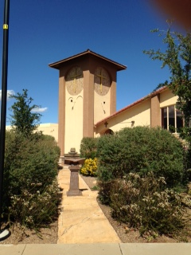

September Readers & Ushers

September 6
Samuel Thorington

September 13
Pastor George McGuire

September 20

Suzanne Roberts

September 27

Bob Gilbert

Please Sign up


September 2026
Immanuel Lutheran Church
2145 S. Coronado Dr.
Sierra Vista, AZ 85635
www.grace2u.org: (520)458-3883
Isaiah 26:4

Trust in the Lord forever, for the Lord God is an everlasting rock.

by Pastor Gary M. Brown
Why Don’t Lutherans Speak Much About Sanctification?

Sanctification defined: Holiness, to be set apart, consecration, purification, the effect of consecration, sanctification of heart and life.

We Christians are at the same time sanctified and being sanctified. What? Pastor, I always knew you used to work in politics, but that’s some serious double talk!

No, not at all, you see, we are already set apart for eternity as ones marked with the name of Jesus in our baptism, already declared righteous for His sake, but we are also growing in holiness, we are being changed into the likeness of God.

We hear a lot about being Justified in church, that means to be made right in God’s sight, but why don’t we hear much about sanctification, after all we hear a lot about that on Christian radio.

Lutherans are conspicuously quiet when it comes to sanctification because, opposed to popular belief, we cannot measure our holiness. Consider St. Paul, he called himself the chief of sinners and called himself a worm before God, but who among us can claim to be nearly as holy and righteous as this man who wrote so much of the New Testament?

The problem is that if we look inside of ourselves to see how we are measuring up to God’s perfect righteousness, if we are honest in the least, we will see only sin looking back at us. Furthermore, the more we are aware of God’s presence and righteousness in our lives, the more we will find that we are not sanctified at all. If we look in at our own hearts, we are looking in the wrong direction, for our holiness and righteousness does not come from there, but from Jesus and His sacrifice for us on the cross.
Once again, we are changing the subject from Sanctification to Justification for it is through justification that we are sanctified. When we look to the cross of Jesus Christ we find that, “He who began a good work in you will be faithful to complete it.” When we have a Savior in Jesus, we have one who is the author, and finisher of our faith.

We Lutherans obsess on justification because when we do that, we fix our eyes on Jesus and He gives us all we need for this life and for the next, how much more do you need? Besides, if we talk about how sanctified we are, we are just bargaining on ourselves, but if we must brag, we Christians brag on Jesus.

Next time your “Christian” friend, or the guy on the radio brag about how holy and sanctified they are, congratulate them on their “righteousness,” and then feel free to brag about Jesus and how holy He is. Why don’t Lutherans talk about sanctification? Because we realize that glorifying ourselves is a sin, but glorifying our Savior is a wonderful thing.

An article from Rev. Craig Donofrio

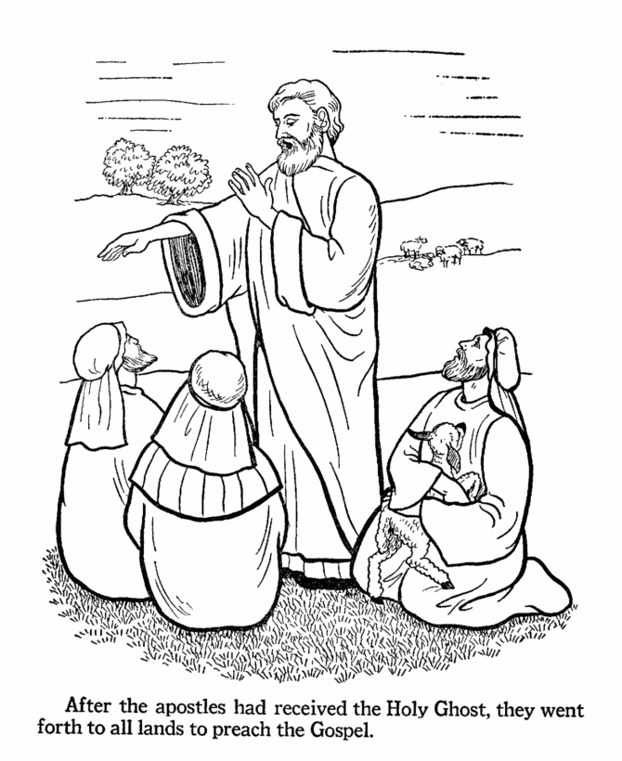

VICAR’S CORNER

Matthew 20:28- “even as the Son of Man came not to be served but to serve, and to give his life as a ransom for many.”

It is interesting how much we can overlook in our services every Sunday. One example that really changed the way that I viewed Christian life was learning about the Divine Service. What does this name actually mean? Who is serving who? While one might think the word service in this name refers to our worshiping God, therefore our service to him, it’s actually the other way around. Every Sunday it is the Lord who serves us in Word and Sacrament. We then thank God in prayer or perhaps a hymn.
This is a reflection of the Christian life. First, we receive. If we take a look at Genesis, it is God who creates and gives life to the first man. Not only that, he gave him his first vocation. (Gen 2:1-15) God continues today to give life, vocation, family, house, and all things. But the most important gift of all, was when our Lord Jesus Christ gave his life that we may have life eternal. We don’t receive any of this because we deserve them, but as a gracious gift from a God who loves us dearly. As we come to Church each Sunday, we once again receive the gifts that our loving God offers us. First, we receive forgiveness in absolution and in the Lord’s supper, and we are strengthened in our faith as well in the supper and as we hear the preaching of the word. As we receive these gifts each Sunday, they prepare us to serve our neighbors in the places where God has called us.

September

Bible Study Opportunities:
- Men’s Bible Breakfast, July September 12 & September 26, 2026 at 9:00A.M.
- Bible Study on Thursday’s at 10:00A.M. in the Friendship Hall.

- Sunday Adult Bible Study after service in the Friendship Hall.

- The Portals of Prayer are available in the Narthex for home study and daily devotions.
“If you’re
going to believe
in everything
you read,

Then start
with your
Bible.”

Quote From Faithimg.com

Birthdays
- 2-Sep Debbie Dinkel
- 11 Sep Karin Graham
- 20-Sep Charlie Yarbrough
- 24-Sep Sherry Arriaga

Wedding Anniversaries
- 2-Sep Warren & Jacqui Pieschke
- 4-Sep Dale & Suzanne Roberts
- 11-Sep Samuel & Rebecca Thorington

General Announcements
“God is your imaginary friend!” Many people could not defend their faith against statements like this. Could You? “…always being prepared to make a defense to anyone who asks you for a reason for the hope that is in you…” (1 Peter 3:15). “Jesus never said He was God.” “Noah couldn’t put that many animals in the ark.” If you would like to understand why the Bible is true and how to defend your Christian faith, join us at our Sunday Bible Study hour for a special class called “Systematic Theology.” The class has begun. There is a workbook for this class, the church has purchased more workbooks and are available for this special class. I encourage you to take advantage of this weekly study, you will be greatly blessed as you learn to be a knowledgeable witness for Christ.

The Board of Education –are in need of teachers, both regular and substitutes.

Fellowship Kitchen Helpers – We are looking for volunteers to help out in the kitchen during Fellowship time on Sundays. There are only a few members, who have been very dedicated, to provide this wonderful service to our congregation and those numbers are now waning. The current volunteers will be more than helpful in showing you all you need to know in how it is run and assisting you, so please prayerfully consider becoming a Kitchen Helper. You will be a blessing and will also be blessed when you use your time and talents in helping out at the church in whatever capacity you can! Please contact Pam Germeroth if you are interested in helping in the kitchen.

Men’s Bible Breakfast – The next Men’s Bible Breakfast will be on September 12, & September 26, 2026 from 9am to 10:30am. All gentlemen are invited and are welcome to bring a guest.

Council Meetings – The Council meetings are open to the membership. Council meetings are held on the second Tuesday of the month at 6:30 pm in the Fellowship Hall. The next Council meeting will be held on September 8, 2026. This is a good opportunity to voice concerns, present thoughts and ideas, and any other discussion concerning the affairs of Immanuel.

Crafty Ladies -Going forward, Crafty Ladies will meet once a month, on the second Monday of each month from 10:00 am – 2:00 pm. The next Crafty Ladies Meeting will be on September 14, 2026. Any questions about the changes please call or text Lu Del Livingston at (505) 870-1495.

LWML – Will be having their meeting on September 14th at 1:00 pm in the Fellowship Hall.

Sunday Adult Bible Study – We are having Bible study right after Sunday Service and Fellowship time in the Friendship Hall.
Lay Reader and Ushers Sign-up Sheets – Thank you to all who have felt led to read the lessons on Sunday mornings. Thank you to all who have served us by being Ushers at our Church service. Our next quarter’s sign-up sheet is on the board in the Narthex. We REALLY need USHERS.
Good Neighbor Alliance – There are baskets under the mail boxes in the Narthex, where we collect food, toiletries, and socks for the needy in our community. There is a list in the Narthex of their current needs. Some of the most urgent are: Cereal, Oatmeal, Breakfast Bars, Paper Towels, All Purpose Cleaner, Coffee, and Travel Size Shampoo.

Fry’s shoppers – Are you signed up for Fry’s community rewards? If not, consider signing up under Immanuel Lutheran Church LWML and you will earn rewards that will come to the church while still accumulating your own rewards.

IMMANUEL LUTHERAN COUNCIL MINUTES AUGUST 11, 2026
ATTENDANCE-Eddie Yarbrough, Vicar Tanner, Debbie Dinkel, Chuck Potucek, Dawn Wilson,
Bob Gilbert, Ken Mette, Yulonda Boutte and Lawrence Boutte, Susan Miller, Darlene Oetgen
CALL TO ORDER-Chuck Potucek at 6:35pm
OPENING PRAYER-led by Vicar Tanner
MOTION TO APPROVE JULY MINUTES-1st by Eddie and 2nd by Bob, all approved
PASTOR'S REPORT-Absent. Included in his paperwork Pastor said (1) no gains or losses in
membership. (2) He has made visitation contacts in person, by phone and text. (3) Vicar
Tanner will be preaching on August 23. (4) Sunday August 9 will begin the Systematic
Theology class. (5) Bible studies will be Sunday, Thursday and 2nd and last Saturday Men's
Bible breakfast. (6) New website is immanuellutheranchurchsv.com (7) We have a back drop
for our devotion "Take Five with Pastor Brown" (8) Vacation TBA due to vicar supervision.
PRESIDENT REPORT-Chuck said he will talk about our insurance needs in Business. We need to
discuss new goals for next year and the sanctuary roof project. It is almost time (Oct) to apply
for new vicar. We will use the same nominating committee.
Ken Mette arrived late and asked if we have a password for domain grace2u.org. Discussion
around whether that domain will be kept. Ken will try to talk to Bruce Phillips about the
password.
VICE PRESIDENT-absent
FINANCIAL-Dawn for July church made $32,000+. A member called regarding his donations whether the donation can be given to the church and then donated to a particular person who
isn't a member. Much discussion followed. It was said that donating person could not do that
and expect a tax reduction. This would have to be voted on by council which will be new
business next month.
TREASURER-Debbie says Mortgage has been paid off. All funds coming in now will go toward
the roof. DCE fund should go to Vicar fund. From Taggart's parents and has been sitting for
quite a while. We need Taggart's permission.
BOARD OF ED-Yulonda says we need more S.S. teachers. We will have rally day. Mortgage
burning will take place Oct. 11 along with a potluck. Safe deposit box will save our deed.
ELDERS-Eddie said two items were discussed at their meeting. (1) Stewardship drive is
upcoming to find people to serve on boards. A slate for candidates will be available at the
next voter's meeting in Nov. Jim Schroeder has resigned from the elders and Jack Shaddy will
be moving. (2) they talked about insurance requirements regarding the risk of sexual
misbehavior. He said it can be discussed further in new business.
EVANGELISM-No members. It does need to be filled
STEWARDSHIP-Bob had a call with David Loeffelman our ex-member and ex Stewardship
leader. For the month of July, we are up $8400. Special gifts were given.
TRUSTEES-Ken received phone call from Pacific Networks. They wanted to know the situation
on the water. They are supposed to maintain it the first year and after that we are responsible.
We have to figure out what plants we want and how to get the water working. Ken is going to
get a quote to take care of the situation. Debbie said we could use a hose until we decide
what we will need. Ken will be having surgery August 31.and he has Steve Dinkel and Vicar
Tanner to help with the mowing. Ken contacted 5 companies and 4 companies were booked
through Sept. The 5th company is too expensive. Lawrence will try to contact a company.
ALTAR-0
HOSPITALITY-0
DECORATIONS-0
LWML-Susan said we will have first meeting October 4.
MOTION FOR APPROVAL OF ABOVE REPORTS-1st-Lawrence 2nd-Ken. All approve
NEW BUSINESS-We need to do background checks. We have been vastly out of compliance
with insurance company. We need trainings/policies. Chuck has been gathering information.
He will call insurance agent regarding what we really need to do. Costs will be involved.
LORD'S PRAYER
ADJOURNED-7:41pm

September 2026
SUNDAY | MONDAY | TUESDAY | WEDNESDAY | THURSDAY | FRIDAY | SATURDAY
 |  | 1 | 2 | 3  Bible Study 10:00am | 4 | 5
6  Elder’s Meeting 12:30pm | 7  Labor Day | 8  Council Meeting 6:30pm | 9 | 10  Bible Study 10:00am | 11 | 12  Men’s Bible Breakfast 9:00am
13 | 14  Crafty Ladies 10:00am-2:00pm  LWML 1:00pm | 15 | 16 | 17  Bible Study 10:00am | 18 | 19
21 | 22 | 23 | 24 | 25  Bible Study 10:00am | 26 | 27  Men’s Bible Breakfast 9:00am
28  Mite Sunday | 29 | 30
If you would like information, or an article put into the Newsletter, please send it to the office by the 15th of the month. If you do not see your birthday or anniversary included and would like to have it in the Newsletter, please notify the office to update our lists.

