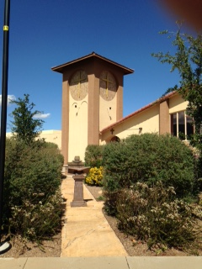

August Readers & Ushers

August 2
Pastor George McGuire
Lawrence & Yulonda Boutte

August 9
Suzanne Roberts

August 16

Samuel Thorington

August 23

Bob Gilbert

August 30
Sean Curnyn
Please Sign up


August 2026
Immanuel Lutheran Church
2145 S. Coronado Dr.
Sierra Vista, AZ 85635
www.grace2u.org: (520)458-3883
Matthew 19:14
but Jesus said, “Let the little children come to me and do not hinder them, for to such belongs the kingdom of heaven.”

by Pastor Gary M. Brown

The Vicar is Here!
Vicar Tanner has arrived. He will begin Sunday, August 2. I need your help! Tanner is in his 3rd year of Seminary education, and he will be here for one year. Think of him as an intern, he is primarily here to learn. While he is here, he will be putting hands on nearly every aspect of ministry. Treat him like a pastor, ask him questions, get his help, get advice or give some. Just bear in mind, he is not a pastor yet but a student. Following his year -long vicarage he will return to seminary in St. Louis for his last year of academic study. Pray for him, help him, love him the way that you have loved me as I know you will. May the God of all grace be with you, as together you and I, and Tanner work laboring in the Gospel for the salvation of all. Amen!

Do you know what you believe, and why you believe it:
Next Sunday, 9 August at 11AM we begin our Systematic Theology Class. We will be reviewing core Christian beliefs, why we believe them and how to defend them. This class will be very helpful in solidifying what we believe, and it will embolden us for explaining it to others in our lives. There is a workbook for this class, while it is free to you, I would ask you to reserve a copy by calling the office. This will ensure that we have a book available for each of you.

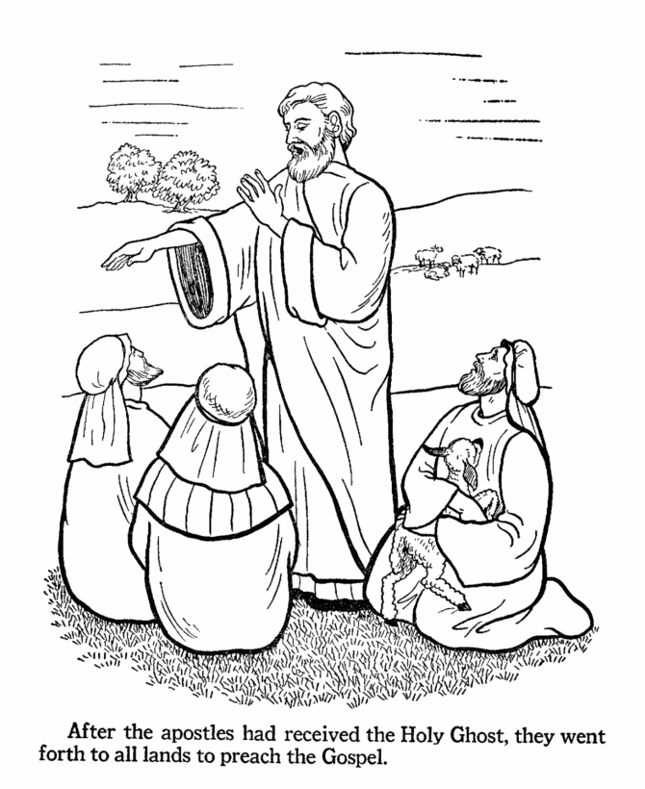

August

Bible Study Opportunities:
- Men’s Bible Breakfast, July August 8 & August 29, 2026 at 9:00A.M.
- Bible Study on Thursday’s at 10:00A.M. in the Friendship Hall.

- Sunday Adult Bible Study after service in the Friendship Hall.

- The Portals of Prayer are available in the Narthex for home study and daily devotions.
“If you’re
going to believe
in everything
you read,

Then start
with your
Bible.”

Quote From Faithimg.com

Birthdays
- 3-Aug Matthew Beckley
- 5-Aug Tina Hungerford
- 8-Aug Anna Biondi
- 8-Aug Sam Conroy
- 8-Aug Michael Potucek
- 13-Aug Rob Yancey
- 18-Aug June Osten
- 19-Aug Mark Potucek
- 19-Aug Ron Witt
- 20-Aug Warren Pieschke
- 21-Aug Dottie Dilda
- 21-Aug Sean Curnyn
- 23-Aug Janice Benavides
- 29-Aug Seth Fuller
- 30-Aug Rick Rambo

Wedding Anniversaries
- 15-Aug Jim & Char Behnke
- 23-Aug Matt & Dawn Wilson

General Announcements
“God is your imaginary friend!” Many people could not defend their faith against statements like this. Could You? “…always being prepared to make a defense to anyone who asks you for a reason for the hope that is in you…” (1 Peter 3:15). “Jesus never said He was God.” “Noah couldn’t put that many animals in the ark.” If you would like to understand why the Bible is true and how to defend your Christian faith, join us at our Sunday Bible Study hour for a special class called “Systematic Theology.” The class begins on August 9th. There is a workbook for this class, the church has purchased 20 workbooks and will be available on August 9th for this special class. I encourage you to take advantage of this weekly study, you will be greatly blessed as you learn to be a knowledgeable witness for Christ.

The Board of Education – will kick off the new Sunday School year on August 30th with Rally Day. There will be games and ice cream sundaes for all. We are also in need of teachers, both regular and substitutes.

Fellowship Kitchen Helpers – We are looking for volunteers to help out in the kitchen during Fellowship time on Sundays. There are only a few members, who have been very dedicated, to provide this wonderful service to our congregation and those numbers are now waning. The current volunteers will be more than helpful in showing you all you need to know in how it is run and assisting you, so please prayerfully consider becoming a Kitchen Helper. You will be a blessing and will also be blessed when you use your time and talents in helping out at the church in whatever capacity you can! Please contact Pam Germeroth if you are interested in helping in the kitchen.

Men’s Bible Breakfast – The next Men’s Bible Breakfast will be on August 8 & August 29, 2026 from 9am to 10:30am. All gentlemen are invited and are welcome to bring a guest.

Council Meetings – The Council meetings are open to the membership. Council meetings are held on the second Tuesday of the month at 6:30 pm in the Fellowship Hall. The next Council meeting will be held on August 11, 2026. This is a good opportunity to voice concerns, present thoughts and ideas, and any other discussion concerning the affairs of Immanuel.

Crafty Ladies -Going forward, Crafty Ladies will meet once a month, on the second Monday of each month from 10:00 am – 2:00 pm. The next Crafty Ladies Meeting will be on August 10, 2026. Any questions about the changes please call or text Lu Del Livingston at (505) 870-1495.

Sunday Adult Bible Study – We are having Bible study right after Sunday Service and Fellowship time in the Friendship Hall.
Lay Reader and Ushers Sign-up Sheets – Thank you to all who have felt led to read the lessons on Sunday mornings. Thank you to all who have served us by being Ushers at our Church service. Our next quarter’s sign-up sheet is on the board in the Narthex. We REALLY need USHERS.
Good Neighbor Alliance – There are baskets under the mail boxes in the Narthex, where we collect food, toiletries, and socks for the needy in our community. There is a list in the Narthex of their current needs. Some of the most urgent are: Cereal, Oatmeal, Breakfast Bars, Paper Towels, All Purpose Cleaner, Coffee, and Travel Size Shampoo.

Fry’s shoppers – Are you signed up for Fry’s community rewards? If not, consider signing up under Immanuel Lutheran Church LWML and you will earn rewards that will come to the church while still accumulating your own rewards.

RALLY DAY



The Board of Education will kick off the Sunday School new year on August 30th with Rally Day. There will be games and ice cream sundaes for all.

IMMANUEL LUTHERAN COUNCIL MINUTES JULY 14, 2026

CALL TO ORDER-Chuck Potucek at 6:35 pm
OPENING PRAYER-Pastor Brown
APPROVAL OF JUNE 16, 2026 MINUTES-Eddie/Ken, approved
ATTENDANCE-Debbie Dinkel, Lawrence and Yulonda Boutte, Ken Mette, Eddie Yarbrough, Susan Miller, Pastor Brown, Bob Gilbert, Darlene Oetgen, Chuck Potucek
PASTOR’S REPORT-See report, plus talked about new SS class beginning August 9. Books are needed so Pastor will ask Lisa to order 20 for attendees.
PRESIDENT-Chuck said he met with Tanner Gossman, our upcoming vicar and his family and had a very good meeting. Sunday’s voter’s meeting will include: 1) Vicar update by Eddie, 2) Vicar compensation package update by Sid, 3) Sanctuary project recap by Ken, 4) next building project-the roof-Chuck, 5) Victoria will update on the tower, 6) Constitution and Bylaw update by Lawrence, 7) Form a nominating committee for the October Voter’s Meeting
VICE PRESIDENT-Lawrence said everything is ready for the vote on Sunday for the updated Constitution and Bylaws. A ¾ vote of those present is required for the Constitution and a 2/3 vote is required for the Bylaws.
The above was recorded by Debbie as Darlene was late to meeting.
Following is reported by Darlene
TREASURER-Debbie said today mortgage is currently around $8,000. We will be paying off our 20-year mortgage 10 years early.
Discussion regarding burning our mortgage on August 30, Rally Day.
Our savings account is $60,909.00 +
EDUCATION-Yulonda said Rally Day is August 30, we need more kids and teachers. She needs two white boards. She was told one is in storage for her. There is leftover SS material which is available for anyone who wants it. Marana Church was mentioned.
ELDERS-Eddie said they had no regular meeting, no decisions made. He met with Tanner who will integrate in our community on 8/16 and help with Communion.
STEWARDSHIP- Bob said we are up approximately $6,000 for May and June. He is in the process of rebuilding the spreadsheets. He would like the January through April income reports.
TRUSTEES-Ken said (1) lights are on in the sanctuary with no complaints about them being too bright yet. They do have the capability of being dim, but we need to run wiring to do that and John Conroy asks that we wait until sometime between November and February because of the attic heat. (2) The original roof estimate was $53,000.00. It’s another $20,000 if we use metal. This is to do just the sanctuary and tower, not the fellowship hall. (3)I ordered a desk for Tanner. We are supposed to take him to Staples when he arrives. (4) Ken had Faith Landscaping come and look at a dead tree. They looked at all the trees. They said we have bark beetles. They gave Ken a name called Arizona Arborscape. They inject the trees instead of spraying them. After discussion, motion was made by Susan, seconded by Eddie, for Ken to continue with 19 tree injections @ $3500. All in favor. (5) Irrigation has been off since 2016. Discussion revolved around getting water to the area in front of cell tower behind the church. Right now, we have monsoon water and we can discuss the water irrigation in the future.
ALTAR-
HOSPITALITY-
ABOVE REPORTS APPROVED-1st by Lawrence, 2nd by Debbie,
UNFINISHED BUSINESS-
NEXT MEETING-August 11, 6:30 pm
LORD’S PRAYER
ADJOURNED-7:40pm

August 2026
SUNDAY | MONDAY | TUESDAY | WEDNESDAY | THURSDAY | FRIDAY | SATURDAY
 |  |  |  |  |  | 1
2  Installation of Vicar Tanner  Elder’s Meeting 12:30pm | 3 | 4 | 5 | 6  Bible Study 10:00am | 7 | 8  Men’s Bible Breakfast 9:00am
9 | 10  Crafty Ladies 10:00am-2:00pm | 11  Council Meeting 6:30pm | 12 | 13  Bible Study 10:00am | 14 | 15
16 | 17 | 18 | 19 | 20  Bible Study 10:00am | 21 | 22
23 | 24 | 25 | 26 | 27  Bible Study 10:00am | 28 | 29  Men’s Bible Breakfast 9:00am
30  Mite Sunday  Rally Day with ice cream sundaes | 31
If you would like information, or an article put into the Newsletter, please send it to the office by the 15th of the month. If you do not see your birthday or anniversary included and would like to have it in the Newsletter, please notify the office to update our lists.

