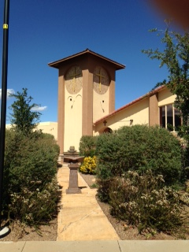

October Readers & Ushers

October 4
Suzanne Roberts
Tina Hungerford
Yulonda Boutte

October 11
Sean Curnyn

October 18

Samuel Thorinton

October 25

Steve Kron

Please Sign up


October 2026
Immanuel Lutheran Church
2145 S. Coronado Dr.
Sierra Vista, AZ 85635
www.grace2u.org: (520)458-3883
Romans 15:6

that together you may with one voice glorify the God
and Father of our Lord Jesus Christ.

by Pastor Gary M. Brown
Authentic, Biblical Christianity

“He cannot have God as his Father, who does not take the Church as His Mother.”
St. Augustine

What St. Augustine is saying is it’s not acceptable for a believer to disassociate themselves with the Church, the Fellowship of the Saints, or (The Body of Christ). BUT…

In a world filled with so many options, how do you choose the right church for you? May I suggest it’s all about Jesus!
Afterall, we are CHRISTians. It is Jesus Christ whom we worship, and from whom we receive all the gifts of heaven, including Eternal Life.

When Christians gather, Jesus should be the One around whom they gather. Jesus and His finished work for you must be the message every time the Church gathers.
- He Lived a perfect and sinless life in our place.
- He Died on a cross and paid in-full the Debt for our sins.
- He rose victoriously over death & Hell, so we too will rise from the dead.
- He feeds us with His Word and the Sacraments.
- He has secured eternity for us, because He Loves us.

Jesus loves you too!
Many believe that God could never love them because of their sin! But, the message of the Cross is a message of forgiveness and acceptance for sinners just like you! Jesus has made us friends of God. That gift is for all people regardless of your sin, age, gender, nationality, religion, or personal preferences. Jesus loves all! Even you!

This message is called the GOSPEL!
The Gospel is a happy message, not an angry message. It is God’s free gift of undeserved and unlimited love for you, because of Jesus’ death for you! He neither asks nor expects anything in return. Some churches teach that you must do things to earn or deserve God’s love or forgiveness. Others believe that you have to be good to be a Christian or to go to Heaven.

That message is called the LAW!
The Law has no power to save you from your sin. The Law instead only shows us how far from being good we really are. But still, that is what some preach. If people could be good enough, Jesus would not have needed to die. Trusting in our own goodness or our ability to be good is a deadly trap. We must rely on the work of Jesus and trust that His work was more than enough for us.

This trust is called FAITH!
Faith is a gift of God, and only by faith in Jesus’ finished work for us can we receive the love and forgiveness of God the Father.

God’s Love and acceptance is called GRACE!
“For by grace you have been saved through faith. And this is not your own doing; it is the gift of God, not a result of works, so that no one may boast.” (Eph. 2:8-9)

If all Churches presented this message faithfully and consistently, it would be easy to choose a church. Sadly, they don’t all preach the message of the cross (the Gospel). Be sure that when you go to worship at any Church, before you join that they preach the Good News every Sunday as the last and final Word for Salvation. If they don’t, go find one that does… Your Soul depends upon believing this Good News!

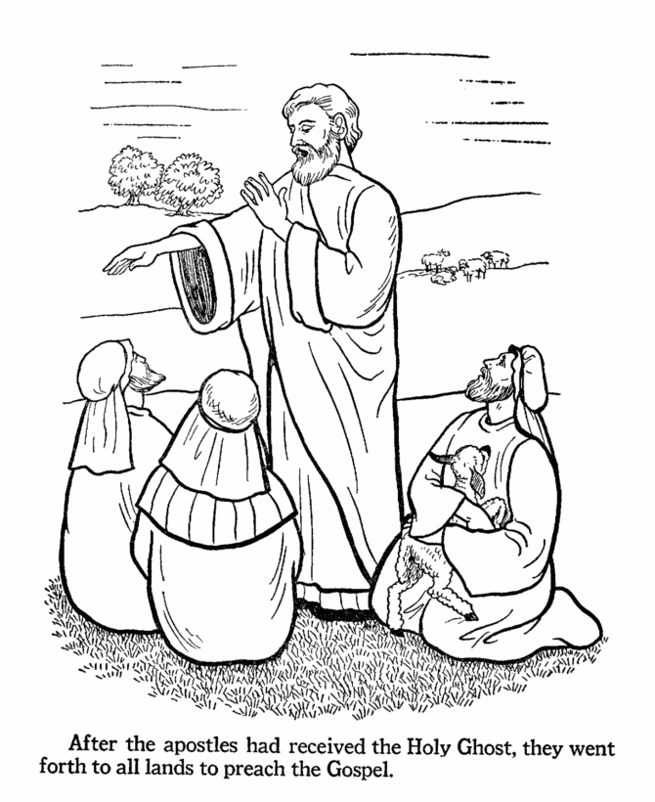

VICAR’S CORNER
Christological Reading

This past Sunday some of you joined me for Bible study where we talked about some of the literary features in Jonah and we briefly discussed Christological reading. What does this mean? Jesus tells us in the Gospel of John that all of the Scriptures point towards him. (John 5:39-47) This is something that Christians know, but I think many don’t know how to apply this principle to their own devotional life.
An example that came up Sunday is Jonah sleeping in the boat when there was a storm. I was asked if there is any significance between Jonah sleeping in a boat (Jonah 1:5) and the Story of Jesus falling asleep in a boat with the disciples. (Matthew 8:23-27). There absolutely is! When we read the Old Testament, we can see “types” of Christ. These types foreshadow or point to Christ through their words and actions. When you read about Daniel and the Lion’s den we are reminded of Christ and the Tomb. Just as we are when Jonah spends time in the big fish.(Matthew 12:38-42)
What you’ll notice when you start to find these foreshadows of Christ to come is that Jesus is always doing something greater and better. Let’s use the example of sleeping during the storm. Jonah gets up and the storm is only satisfied once he is no longer on the boat. Jesus gets up and commands the storm to be still and it listens. So what does this mean? Jonah and Jesus were both prophets, but Jesus is greater than Jonah. Being the living God, he has control over all of creation.
When you learn to read the scriptures Christologically you are welcomed into a new world of depth and meaning that points us to our Savior from which we receive ever lasting life.

May the Lord bless and you keep you always focused on that fount from which we receive that life, which is Christ.

Vicar

October

Bible Study Opportunities:
- Men’s Bible Breakfast, October 10, & October 24, 2026 at 9:00A.M.
- Bible Study on Thursday’s at 10:00A.M. in the Friendship Hall.

- Sunday Adult Bible Study after service in the Friendship Hall.

- The Portals of Prayer are available in the Narthex for home study and daily devotions.
“If you’re
going to believe
in everything
you read,

Then start
with your
Bible.”

Quote From Faithimg.com

Birthdays
- 1 - Oct Carol Chamberlain
- 1 - Oct Ariel Conroy
- 1 – Oct Pat Weller
- 7 – Oct Daniel Harney
- 7 – Oct Jim Schroeder
- 8 – Oct Kenneth Chamberlain
- 9 – Oct Ben Berger
- 10 – Oct John Conroy
- 12 – Oct Julie Berger
- 16 – Oct L. J. Boutte Jr.
- 21 – Oct Ben Benavides
- 25 – Oct Bert Hyland

Wedding Anniversaries
- 1 – Oct Ty & Stephanie Block
- 7 – Oct Sean & Denise Curnyn
- 8 – Oct Steve & Debbie Dinkel
- 23 – Oct Don & Joey Pfeiffer
- 26 – Oct Seth & Cheryl Lyn Fuller

General Announcements
“God is your imaginary friend!” Many people could not defend their faith against statements like this. Could You? “…always being prepared to make a defense to anyone who asks you for a reason for the hope that is in you…” (1 Peter 3:15). “Jesus never said He was God.” “Noah couldn’t put that many animals in the ark.” If you would like to understand why the Bible is true and how to defend your Christian faith, join us at our Sunday Bible Study hour for a special class called “Systematic Theology.” The class has begun. There is a workbook for this class, the church has purchased more workbooks and are available for this special class. I encourage you to take advantage of this weekly study, you will be greatly blessed as you learn to be a knowledgeable witness for Christ.

The Board of Education –are in need of teachers, both regular and substitutes.

Fellowship Kitchen Helpers – We are looking for volunteers to help out in the kitchen during Fellowship time on Sundays. There are only a few members, who have been very dedicated, to provide this wonderful service to our congregation and those numbers are now waning. The current volunteers will be more than helpful in showing you all you need to know in how it is run and assisting you, so please prayerfully consider becoming a Kitchen Helper. You will be a blessing and will also be blessed when you use your time and talents in helping out at the church in whatever capacity you can! Please contact Pam Germeroth if you are interested in helping in the kitchen.

Men’s Bible Breakfast – The next Men’s Bible Breakfast will be on October 10, & October 24, 2026 from 9am to 10:30am. All gentlemen are invited and are welcome to bring a guest.

Council Meetings – The Council meetings are open to the membership. Council meetings are held on the second Tuesday of the month at 6:30 pm in the Fellowship Hall. The next Council meeting will be held on October 13, 2026. This is a good opportunity to voice concerns, present thoughts and ideas, and any other discussion concerning the affairs of Immanuel.

Crafty Ladies -Going forward, Crafty Ladies will meet once a month, on the second Monday of each month from 10:00 am – 2:00 pm. The next Crafty Ladies Meeting will be on October 12, 2026. Any questions about the changes please call or text Lu Del Livingston at (505) 870-1495.

Special Speaker–Arizona Origin Science Association (AZOSA) speaker, Jay Seagert will be speaking on October 21st at 6:30 pm.

Sunday Adult Bible Study – We are having Bible study right after Sunday Service and Fellowship time in the Friendship Hall.
Lay Reader and Ushers Sign-up Sheets – Thank you to all who have felt led to read the lessons on Sunday mornings. Thank you to all who have served us by being Ushers at our Church service. Our next quarter’s sign-up sheet is on the board in the Narthex. We REALLY need USHERS.
Good Neighbor Alliance – There are baskets under the mail boxes in the Narthex, where we collect food, toiletries, and socks for the needy in our community. There is a list in the Narthex of their current needs. Some of the most urgent are: Cereal, Oatmeal, Breakfast Bars, Paper Towels, All Purpose Cleaner, Coffee, and Travel Size Shampoo.

Fry’s shoppers – Are you signed up for Fry’s community rewards? If not, consider signing up under Immanuel Lutheran Church LWML and you will earn rewards that will come to the church while still accumulating your own rewards.

Newsletter Item for
Lutheran Women In Mission (LWML)
October 2026

We will be holding our annual pie/cake sale Sunday, Nov. 22nd. We welcome all donations from our wonderful bakers. We really appreciate all the “shoppers”, who will take the goodies home. Your generous donations will help with supplies for our Crafty Ladies ministry.
Ladies, (young and mature) mark your calendars for Sunday,
December 6th from 1pm to 3pm for our annual ornament/cookie or candy exchange. Bring an ornament and a dozen or your best cookies or candies to share.
We want to thank all who support missions with your Mites, you bring each month. A special thanks to Ken for singing “Dropping Pennies”.
Our next meeting will be November 9th at 1pm here at the church.
IMMANUEL LUTHERAN COUNCIL MINUTES
SEPTEMBER 8, 2026

ATTENDANCE-Vicar Tanner, Eddie Yarbrough, Chuck Potucek, Debbie Dinkel, Darlene Oetgen, Yulonda and Lawrence Boutte Susan Miller, Dawn Wilson, Pastor Brown
CALL TO ORDER-Made by Chuck at 6:32 pm
PRAYER-Said by Vicar Tanner
Susan commented that minutes regarding LWML need to be corrected. Susan says First LWML meeting is September 14 after Crafty Ladies. Oct. 4 is LWML Sunday.
MOTION TO APPROVE MINUTES-1st by Eddie and 2nd by Yulonda. All in favor.
PASTOR BROWN’S REPORT- (1)He spoke with a pastor who will be working with Vicar Tanner to give him more experience with Spanish Ministry (2) Pastor’s wife, Kim, is now at Life Care. Prayers appreciated. (3) Ken Mette is now at Donna Graybill’s trailer after his surgery. Pastor thought he sounded great. (4) David Lobb may not be able to do the online videos for awhile. (5) he gave us the dates Vicar will be preaching and his other work. Systematic Theology Class mentioned for Sunday School and the Saturday Men’s Bible studies. AzOSA=Arizona Origin Science Association. will be sending speaker, Jay Seegert, to ILC Oct. 21, at 6:30 pm to speak on the subject of Dinosaurs and The Bible. Free will Offering for the speaker. (6) Phoenix Valdez has been working on our new website, grace2u.org. (7) David Lobb has provided a back drop for our devotion “Take Five With Pastor Brown” which will be posted online, along with our Systematic Theology Sunday Class.
VICAR’S REPORT- Vicar Tanner Will begin visiting shut ins with Pastor McGuire Sept 9. Vicar Tanner visited Patti Stump for house blessing.. Visited Pastor and wife Kim. Vicar Tanner has preached one sermon. He began teaching the high school Sunday school class on Sept. 6. Continues his school work.
PRESIDENT’S REPORT-(1) Chuck said we should probably put off mowing til the rain stops as Ken is not able to mow. Vicar offered to help mow which he can do, but it’s not a requirement. (2) Donna Graybill is head usher and would like to see more people willing to help with ushering. It will be put in bulletin and maybe on the board in entrance. (3) Chuck called the insurance company to get information regarding us building a church policy. People that need background checks would be the church council,Elders, money handlers, SS teacher and helpers, and paid workers. The background checks are essentially the same as getting those on base. There is online training available. (4) Draft of slate of officers will be available October 13 at next council meeting. (5) Voter’s meeting is scheduled for Nov. 15. (6) Funds will be collected for Building funds (no longer called Above & Beyond) Our major project for next year will be collecting funds for the sanctuary roof.
Chuck gave info to Eddie regarding Brenda Schultz asking for use of our facility for a Daughters of America Revolution event in the future.
VICE PRESIDENT-Lawrence said they worked on constitution bylaws that will be sent to district for approval.
FINANCIAL-Dawn said we are doing well. August income was $26,700.
TREASURER-Debbie said everything is pretty normal and everything from the mortgage will go to the Building Fund. ( no longer called Above and Beyond). Building funds will go toward sanctuary roof. Oct. 11 is the date for burning our old mortgage. Suggestion was made to have BRATS FOR TOTS that day. It is a toy fundraiser that the firefighters do.
BD. OF EDUCATION-Yulonda says Sunday School has started. Wish we had more students. We need ideas for a memorial for former member, Margaret Harney.
BD. OF ELDERS-Eddie said they will meet next Sunday. They are discussing how anonymous donations are made. The IRS has strict rules regarding “Pass Through” donations and how that affects charitable donation tax deductions.to individuals are made.
EVANGELISM-0
STEWARDSHIP-Bob Gilbert is absent
TRUSTEES-Ken Mette is absent.
ALTAR-0
DECORATING-0
LWML-
Susan had one question-who do we contact since Ken Mette is not available as Trustee? Ex. ants in the kitchen. She was told to call Secretary Lisa
MOTION TO APPROVE MINUTES-1st by Eddie and 2nd by Dawn. All in favor.
Next meeting is October 13.
Adjourned at 7:24 pm
Lord’s prayer said by all.

October 2026
SUNDAY | MONDAY | TUESDAY | WEDNESDAY | THURSDAY | FRIDAY | SATURDAY
 |  |  |  | 1  Bible Study 10:00am | 2 | 3
4  LWML Sunday  Elder’s Meeting 12:30pm | 5 | 6 | 7 | 8  Bible Study 10:00am | 9 | 10  Men’s Bible Breakfast 9:00am
11 | 12  Crafty Ladies 10:00am-1:00pm | 13  Council Meeting 6:30pm | 14 | 15  Bible Study 10:00am | 16 | 17
18 | 19 | 20 | 21  AZOSA Speaker 6:30pm Jay Seagert | 22  Bible Study 10:00am | 23 | 24  Men’s Bible Breakfast 9:00am
25  Mite Sunday | 26 | 27 | 28 | 29  Bible Study 10:00am | 30 | 31
If you would like information, or an article put into the Newsletter, please send it to the office by the 15th of the month. If you do not see your birthday or anniversary included and would like to have it in the Newsletter, please notify the office to update our lists.

